**ASSIGNMENT 1**

**Introduction And Fundamentals**

1. What is SDLC?

Software development life cycle. The aim of sdlc is to develop software.

It has 6 steps:

1. Requirement
2. Design
3. Development
4. Testing
5. Deployment
6. Maintenance

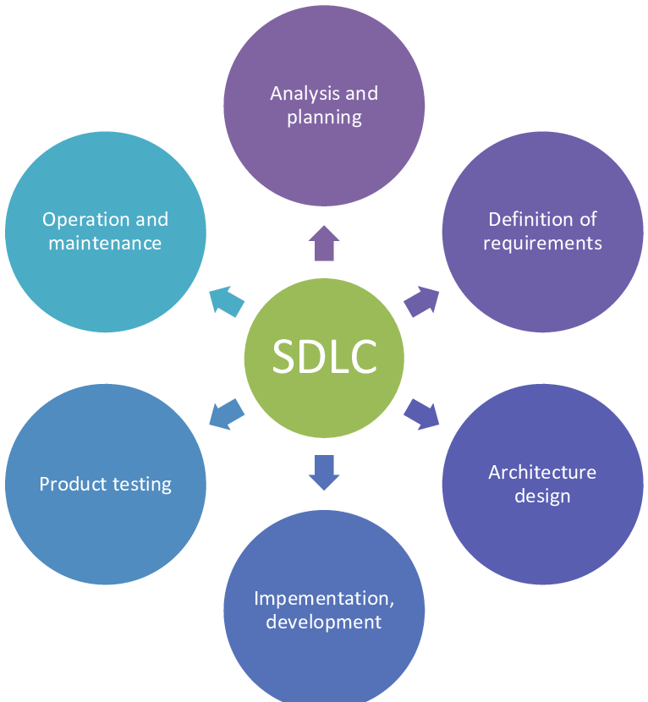

2) What is software testing?

Find bugs, defects or errors from the application or website.

4 steps of testing:

1. Unit testing
2. Integration testing
3. System testing
4. User testing

3) What is oops?

Object-Oriented Programming System.Object-Oriented Programming (OOP), a programming paradigm based on the concept of "objects." These objects can contain data (in the form of fields or attributes) and methods.

* **Encapsulation**: Bundling of data with the methods that operate on it.
* **Inheritance**: Creating new classes based on existing ones.
* **Polymorphism**: The ability of different classes to be treated as instances of the same class through inheritance.
* **Abstraction**: Hiding the complex implementation details and showing only essential features.

4) Write basic concept of oops

Class, object, encapsulation, polymorphism, inheritance, abstraction.

5) What is object?

An object is an instance of a class that represents a real-world entity or concept. It is a combination of:

* **Attributes** (also called fields or properties): These are the characteristics of the object, representing its data. For example, if you have a Car object, its attributes might be color, make, model, etc.
* **Methods** (also called behaviours or functions): These are the actions or operations that the object can perform. For the same Car object, methods might be startEngine(), drive(), etc.

6) What is class?

In Object-Oriented Programming (OOP), a class is a blueprint or template for creating objects. It defines the properties (attributes) and behaviours (methods) that the objects created from the class will have. Classes are a fundamental concept in OOP and are used to implement **encapsulation**, **inheritance**, and **polymorphism**—the core principles of OOP.

7) What is encapsulation?

**Encapsulation** is one of the core principles of Object-Oriented Programming (OOP), and it refers to the practice of bundling the **data (attributes)** and **methods (functions)** that operate on the data into a single unit, which is typically a **class**. It also involves restricting direct access to some of an object’s components, which is known as **data hiding**.

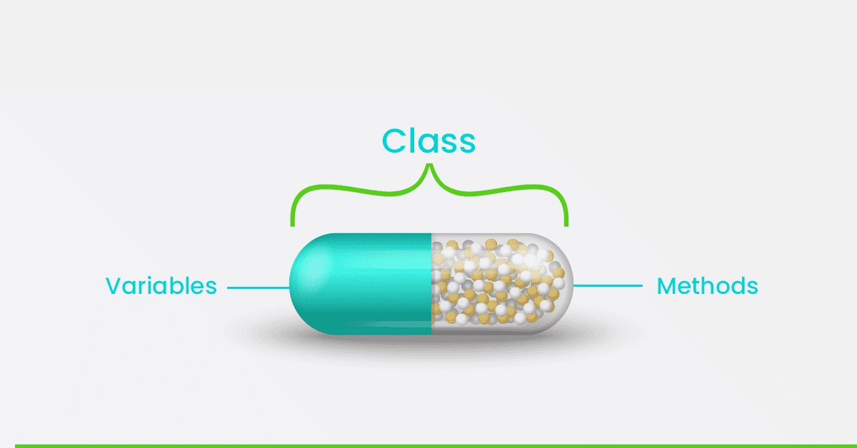

8) What is inheritance?

**Inheritance** is one of the fundamental principles of Object-Oriented Programming (OOP). It allows a new class, called a **child class** (or **subclass**), to inherit properties and behaviours (attributes and methods) from an existing class, called the parent class (or superclass). This promotes **code reuse**, **extensibility**, and the ability to create hierarchical relationships between classes.

8) What is Polymorphism?

Polymorphism is one of the core principles of Object-Oriented Programming (OOP), and it allows objects of different classes to be treated as objects of a common **parent class**. It enables the same method or operation to behave differently based on the object that it is acting upon. it refers to the ability of different classes to respond to the same method call in their own unique way.